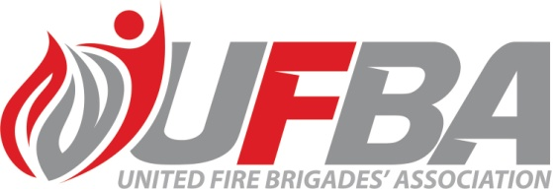

ACCIDENT ASSURANCE SCHEME
The UFBA administers an Accident Assurance Scheme to provide financial assistance to enrolled volunteer fire brigade members who suffer accidents during approved fire brigade activities.
Under the UFBA Accident Assurance Scheme, FENZ volunteers injured in the course of duty can receive payment for loss of wages in the first week of injury and an allowance of 20% of wages for additional time of incapacity to top up the 80% paid by ACC.
Please submit the form and send it to megan@ufba.org.nz within one month of your injury.
(UFBA, Megan Leggett, 86 Main Road, Tawa, Wellington 5024)
Retrospective payments cannot be made.
NOTE - The UFBA makes payments for loss of wages only. Any claims for medical expenses not covered by the ACC should be submitted to your FENZ Region Office. You must supply all relevant information as required before your claim can be processed.
PERSONAL DETAILS OF INJURED PERSON
Name:
Address :

Phone Number:
Email Address:
Brigade:
NATURE OF INJURY (give details)

___________________________________ ____________________________________

____________________________________________________ ____________________

________________________________________________________________________
Please make sure the following requirements are completed and enclosed with your claim.
- ACC18 Medical Certificate that shows the number of days you are not able to work
- ACC Payment Advice and Weekly Compensation Assessment that shows your earning source and gross earnings
- Last 4 weeks of payslips from Employer
- Completed FENZ Accident Report
- Completed Inland Revenue Tax Code Declaration Form using code WT
- Proof of bank account number

ACC SCHEME CLAIM FORM

To: The Chief Executive Officer
UFBA Accident Assurance Scheme

1. I hereby claim the Accident Allowance for TOTAL/PARTIAL disablement through injuries received in connection with the performance of my duties as a member of the

Brigade:

While:

on the day of 20

2. I also confirm that I am not supplementing the Earnings Related Compensation payment established by the Accident Compensation Corporation in any way and my only income during my disability is that assessed by the ACC as Earnings Related Compensation.

3. In addition, I agree to refund any overpayment made to me by the United Fire Brigades’ Association during my incapacity if at any time my total income for the period exceeds 100% of that assessed for the Earnings Related Compensation.

4. I will advise the Chief Executive Officer as soon as practicable of any change or stoppage of Earnings Related Compensation payments.

Signed:

We, the undersigned, verify that met with an accident

(state injuries)

and we consider the injured party is entitled to an allowance for TOTAL/PARTIAL disablement in accordance with the rules of the scheme. We also confirm that to the best of our knowledge, the above statements are correct.
Chief Fire Officer/OIC:

Secretary:

Date:

