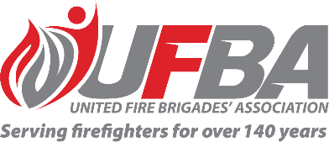
Registration of Interest for UFBA Representative
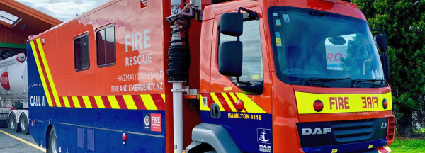

Seeking UFBA Representative for: |  |  | Region Volunteer Support Function Review
Working Group Introduction |  | This project aims to identify any gaps in volunteer support following the introduction of the new Service Delivery structure, assessed against operational needs and the Volunteerism Strategy.
Working Group Purpose for Rep |  | The Advisory Group’s role is to:  - Provide support for the project’s direction and progress at an operational level  - To assist with subject matter expertise  - Assist the project team to deliver within the approved timeframes and acceptable quality
Schedule | To be confirmed |  | Location | To be confirmed
Representative Requirements
Experience | To effectively contribute to this working group, the ideal candidates will have a good, working knowledge of volunteer fire brigades.
Commitment | The successful representative will:  - Attend all required meetings, either in person or online.  - Provide regular progress reports and updates to the UFBA.  - Represent the UFBA and its membership accordingly.

Your Details
Name |  | Brigade, Rank/Role
Phone |  | Email
Please describe your experience relevant to the requirements of this position:

Please complete it and return it to: Jane@ufba.org.nz
If you have any further questions, please feel free to contact Jane: 0274428655

