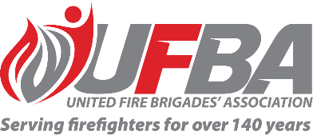

Registration of Interest for UFBA Representative

Seeking UFBA Representative for: |  |  | Working Safely in Water Project – Reference Group
Reference Group Introduction |  | A report issued in 2020 has identified working in and around water as a critical risk. The report also noted “FENZ involvement in water-related rescues has been increasing but the risk management practice is inconsistent across the organisation”.  The purpose of the Reference Group is to bring together stakeholders from within key business units, FENZ, and unions and associations that have an interest or involvement in the Working Safely in Water Project.
Date opened | 16 November 2022 |  | Date closes | 23 November 2022
Schedule | N/A |  | Location | N/A
Representative Requirements
Experience
Commitment | - The Group will meet three times per year, or more frequently as required.  - Meetings will be via Teams. In-person meetings may be arranged if required.  - Online meetings will be no longer than two hours.  - Meetings expected to exceed four hours must be held in-person.
Your Details
Name |  | Brigade, Rank/Role
Phone |  | Email
Please describe your experience relevant to the requirements of this position:

Please return this form by the close date to MAP Administrator, Jane Davie jane@ufba.org.nz

