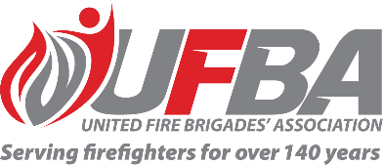

Registration of Interest for UFBA Support Group
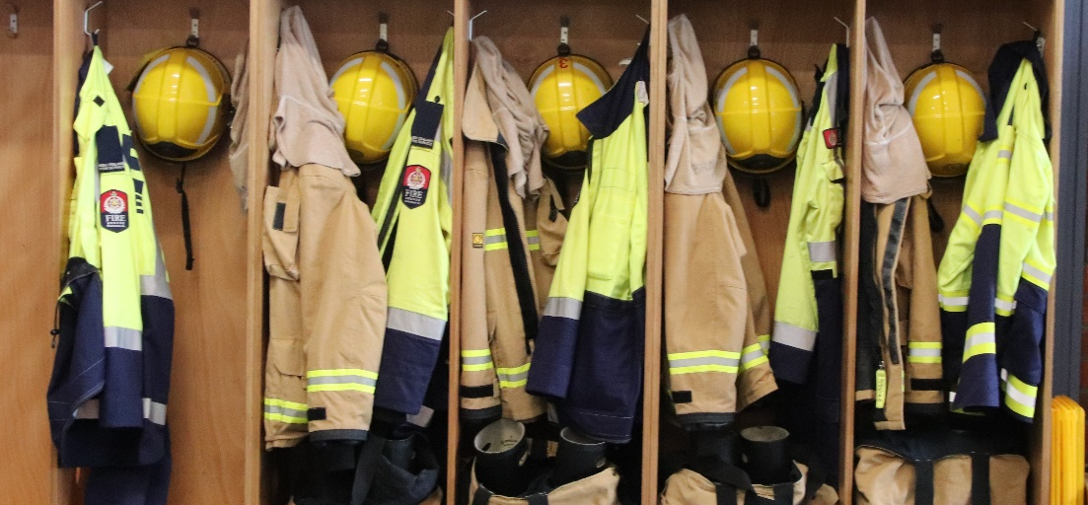

Seeking UFBA Support Group for: |  |  | Uniform Retender Project
Support Group Introduction |  | The UFBA has appointed a representative to the FENZ Uniform Retender Project Reference Group.  We are now establishing a UFBA Support Group consisting of UFBA Members for our representative to meet with and discuss uniform issues, proposals and help shape the submissions put through to Fire and Emergency.  FYI about the FENZ Reference Group: The objective of the Uniforms Retender Project is to establish the necessary process, structure, systems, and supporting mechanisms that will enable FENZ to make a singular approach to the market to secure a new contract for the ongoing design, manufacture, distribution, and logistics services for the uniform items provided currently via the Workwear Group agreement.
Date opened | 6 December 2022 |  | Date closes | 13 December 2022
Schedule | N/A |  | Location | N/A
Support Group Requirements
Experience | We are seeking a group of UFBA members to support our representative on this Reference Group. The Support Group will:  - Assist the representative by being available to discuss matters in preparation for their meetings, and  - Assist the representative by sharing insights to and from your network
Commitment | - The Reference Group will meet every two months for one hour. These meetings may be held face-to-face or via MS Teams.  - Other meetings may be arranged if required
Your Details
Name |  | Brigade, Rank/Role
Phone |  | Email
Please describe why would like to be part of this Support Group and/or any experience relevant to the requirements of this position:

Please return this form by the close date to MAP Administrator, Jane Davie jane@ufba.org.nz

