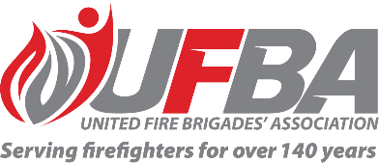

Registration of Interest for UFBA Representative

Seeking a UFBA Representative for: |  |  | FENZ Research and Evaluation to Inform Arson Reduction Strategy and Future Programme Development
Group Introduction |  | The FENZ National Community Readiness and Recovery Directorate are starting a new piece of research focussed on arson reduction. Working in collaboration with Te Ao Marama, the Research and Evaluation Team, the work will inform the creation of an arson reduction strategy and design of a programme, likely to be a first for Fire and Emergency.  Once the researchers have conducted SME interviews and completed their literature review, they will hold a sense-making session to help inform the final report and future strategy. UFBA participation will be both the sense-making session scheduled for approximately 15 March, and in providing feedback for the final report due later in April.
Date opened | 27 January 2023 |  | Date closes | 3 February 2023
Schedule | 15 March (approx.) |  | Location | Microsoft Teams
Support Group Requirements
Experience | To effectively contribute to this Group, the ideal candidate should have experience in arson prevention work and experience in this type of situation.
Commitment | The sense-making session to be held on or around 15 March is likely to be held in Wellington, with the sense-making session will be held virtually over Teams.
Your Details
Name |  | Brigade, Rank/Role
Phone |  | Email
Please describe your experience relevant to the requirements of this position:

Please return this form by the close date to MAP Administrator, Jane Davie jane@ufba.org.nz

