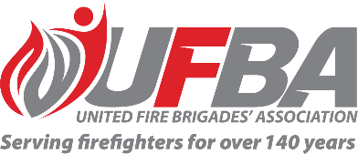

Registration of Interest for UFBA Representative

Seeking UFBA Representative for: |  |  | National Safety, Health and Wellbeing Committee
Committee Introduction |  | This National Safety, Health and Wellbeing Committee is the penultimate body responsible for the overview of safety, health and wellbeing matters.  The National Committee seeks to establish leading practice in safety, health and wellbeing engagement and collaboration as outlined in the Fire and Emergency Safety, Health and Wellbeing Policy Commitment, in the Joint Endorsement Statement with all participating unions and associations representing FENZ’s people and with networks and societies in workplaces.
Date opened | 22 March 2023 |  | Date closes | 29 March 2023
Representative Requirements
Experience | To effectively contribute to this Committee, the ideal candidate should have a sound knowledge of safety, health and wellbeing practices, both within FENZ and the wider community.
Commitment | Attend quarterly meetings (half a day) and attend to urgent matters as required
Your Details
Name |  | Brigade, Rank/Role
Phone |  | Email
Please describe your experience relevant to the requirements of this position:

Please return this form by the close date to MAP Administrator, Jane Davie jane@ufba.org.nz

