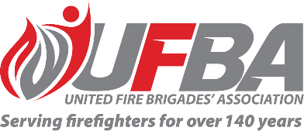

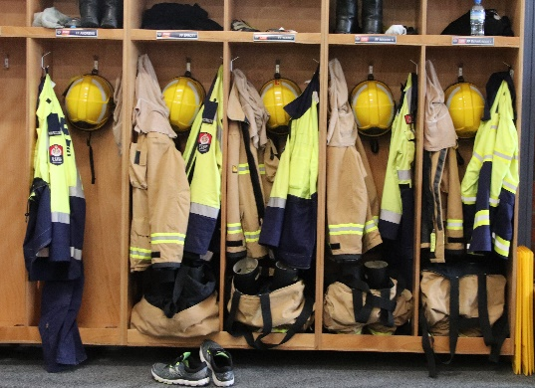
Registration of Interest for UFBA Representative
Seeking UFBA Representative for: |  |  | SF49 Firefighters Personal Protective Equipment Standards Committee
Committee Introduction |  | The work of the SF49 Committee is to review Standards that are due for systematic review or new ones from within the Joint Standards Committee or from ISO Technical Committee responsible for firefighter PPE. The SF49 Committee will send a New Zealand Standards comment to the Joint Standards SF49 Committee for firefighter PPE.
Date opened | 19 May 2023 |  | Date closes | 8 June 2023
Representative Requirements
Experience | To effectively contribute to this Committee, the ideal candidate should have a good understanding of firefighter PPE (preferably with firefighting experience) and understand Standards work and documentation.
Commitment | The representative must be able to participate in online and in-person meetings yet to be scheduled.
Your Details
Name |  | Brigade, Rank/Role
Phone |  | Email
Please describe your experience relevant to the requirements of this position:

Please return this form by the close date to MAP Administrator, Jane Davie jane@ufba.org.nz

