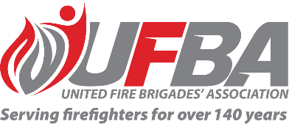
Registration of Interest for UFBA Representative
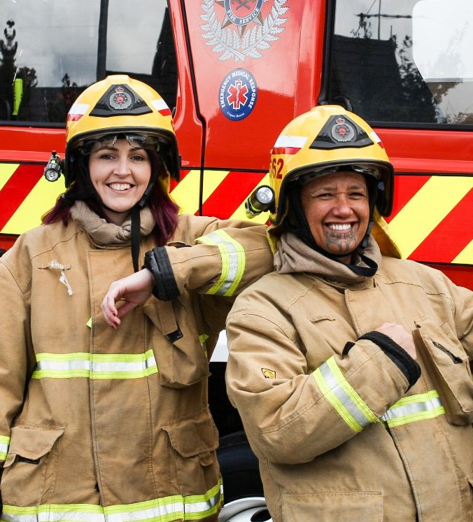

Seeking UFBA Representative for: |  |  | Women Firefighters’ Development Research Project Reference Group
Working Group Introduction |  | Women’s Development and Te Ao Marama are working on a research project that looks at barriers and facilitators women firefighters face in their progression through their career and volunteer roles. The findings from this project will inform how frontline women firefighters can be supported effectively in terms of career experience, or in a wider sense, to create equal opportunities and an inclusive culture for women firefighters to progress to roles that they value.
Schedule | TBA |  | Location | TBA
Representative Requirements
Experience | To effectively contribute to this working group, the ideal candidate will have an understanding of the barriers that face women firefighters in their progression through their career and volunteer roles.
Commitment | The successful representative will:  - Attend all required meetings, either in person or online.  - Provide regular progress reports and updates to the UFBA.  - Represent the UFBA and its membership accordingly.

Your Details
Name |  | Brigade, Rank/Role
Phone |  | Email
Please describe your experience relevant to the requirements of this position:

Return completed form to map@ufba.org.nz by COB Tuesday 2 August 2022.

