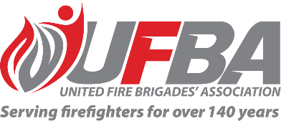

Registration of Interest for UFBA Representative
Seeking UFBA Representative for: |  |  | Public Safety Network Working Group
Working Group Introduction |  | The PSN is a joint programme of work between FENZ, Police, Wellington Free Ambulance, and St John to replace aging networks with modern digital capability. In particular, the focus is on digitising our Land Mobile Radio (LMR), with our current technology in FENZ at its end of life. There is also scope to include personal alerting and priority cellular in this work.
Date opened | 15 November 2022 |  | Date closes | 22 November 2022
Schedule | N/A |  | Location | N/A
Representative Requirements
Experience | To effectively contribute to this working group, the ideal candidate should have a sound appreciation of FENZ operations, and some technical knowledge/project experience may be an advantage.  Our representative will help shape how FENZ implements this technology into our trucks, stations, and COMCENs, helping inform the operational design.
Commitment | A few hours of work each quarter
Your Details
Name |  | Brigade, Rank/Role
Phone |  | Email
Please describe your experience relevant to the requirements of this position:

Please return this form by the close date to MAP Administrator, Jane Davie jane@ufba.org.nz

