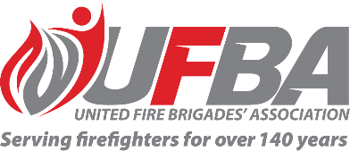

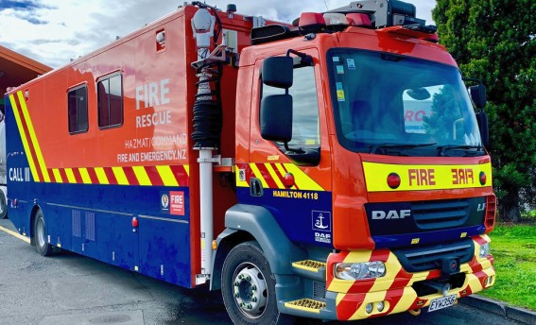
Registration of Interest for UFBA Representative

Seeking UFBA Representative for: |  |  | FENZ Working at Height and Line Rescue Techniques & Equipment
SME Group Introduction |  | This review is a consequence of an OER-targeted review that has identified issues around skills maintenance, location of capability, and equipment. The Working at Heights and Line Rescue policy is being updated to reflect the changes required, so a technical group will need to evaluate equipment and techniques in line with the policy requirements.
Date opened | 24 January 2023 |  | Date closes | 31 January 2023
Schedule | N/A |  | Location | N/A
Support Group Requirements
Experience | To effectively contribute to this SME Group, the ideal candidate should have experience and knowledge in safe working at height, and line rescue.
Commitment | Initially, the members will be expected to participate in Teams meetings when necessary and participate in practical workshops at location/locations to be determined.
Your Details
Name |  | Brigade, Rank/Role
Phone |  | Email
Please describe your experience relevant to the requirements of this position:

Please return this form by the close date to MAP Administrator, Jane Davie jane@ufba.org.nz

