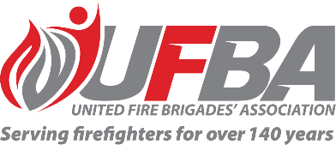

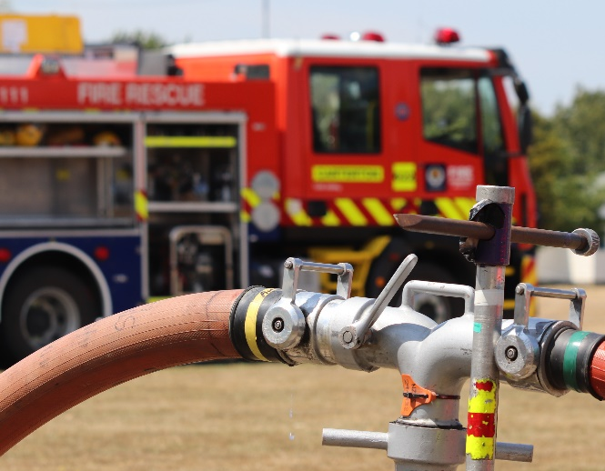
Registration of Interest for UFBA Representative

Seeking UFBA Representative for: |  |  | Code of Practice Firefighting Water Supplies SNZ PAS 4509:2008 (CoPFFWS)
Working Group |  | FENZ is about to begin a piece of work on the review of the CoPFFWS. The review will be conducted by Standards New Zealand with Fire and Emergency New Zealand having seats on the Technical Committee. This Working Group will inform and guide the Fire and Emergency members of the Technical Committee. This project is replacing the current Code of Practice for Firefighting Water Supplies (2008) with a new enabling process and a new overhauled matching Practice of Practice.
Date opened | 15 June 2023 |  | Date closes | 22 June 2023
Representative Requirements
Experience | Phase One of this work is complete (information gathering and understanding what must be changed). To effectively contribute to this Working Group, the ideal candidate should have a clear understanding of the requirements for firefighting water supplies in both urban and rural environments, and be able to participate in project meetings and workshops.
Commitment | The Working Group will be in place for 12 months.
Your Details
Name |  | Brigade, Rank/Role
Phone |  | Email
Please describe your experience relevant to the requirements of this position:

Please return this form by the close date to MAP Administrator, Jane Davie jane@ufba.org.nz

