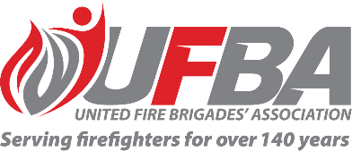
Expression of Interest Form for:
UFBA Volunteer Field Experts Group – TRAINING
Group Overview | This Volunteer Field Expert Group aims to provide a forum that values and acknowledges the expertise within UFBA membership and better enables the UFBA to draw on this expertise, with a focus on volunteer training.  To strengthen the voice of our membership and demonstrate our member's expertise to influence sector-wide FENZ policy and changes over time, especially where changes could impact the delivery of fire and emergency services in local communities.  The UFBA wants to ensure brigades are well-supported by FENZ to serve and protect their communities, and that any changes or implementation is made with the advice of volunteers.
Date open | 21/10/2025 | Date closes | 4/11/2025
Individual Requirements
Expertise & Experience | Preference will be given to candidates who have:  - Specialised knowledge and experience in the area of operational training in built (urban) and natural (rural) environments  - Knowledge of FENZ’s current volunteer training programme  - The ability to represent the UFBA’s diverse wider membership.  - The ability to work collaboratively and professionally to achieve a great outcome for all parties.  - Advantageous to have a training qualification.
Commitment | Group members will convene on an as-required basis

Your Details
Name |  | Brigade, Rank/Role
Phone |  | Email
Please describe your expertise relevant to the requirements of this group. We recommend attaching your CV if you are referring to external experience.

Please describe your experience/interest relevant to the requirements of this group. We recommend attaching your CV if you are referring to external experience.

Please return this form by the close date to connect@ufba.org.nz

