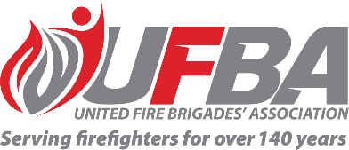
Expression of Interest Form for:
UFBA Volunteer Field Expert Group – PEOPLE EXPERIENCE and culture
Group Overview | This Volunteer Field Expert Group aims to provide a forum that values and acknowledges the expertise within UFBA membership and better enables the UFBA to draw on this expertise, with a focus on the people experience and culture.  There are four FENZ projects and policy reviews in the pipeline that this group will play a role in contributing to:  - Talent and Succession Planning Framework  - Authorising and Decision Making  - Impairment Policy  - Lone Working Policy
Date open | 29/01/2026 | Date closes | 12/02/2026
SME Requirements
Expertise & Experience | Preference will be given to candidates who have:  - Sound understanding of FENZ’s existing policies and procedures.  - The ability to understand and represent the UFBA’s diverse wider membership and fully participate in discussions.  - The ability to work collaboratively and professionally to achieve a great outcome for all parties.  - Advantageous to have external experience in any of the following areas:  - People management, leadership, building strong teams, change management, HR, policy development, health and safety (WorkSafe), risk management.
Commitment | Group members will be required to meet on a regular basis, online (via MS Teams)

Preference will be given to candidates who demonstrate experience in….

Your Details
Name |  | Brigade, Rank/Role
Phone |  | Email
Please describe your expertise relevant to the requirements of this Volunteer Field Expert group. We recommend attaching your CV if you are referring to external experience.

Please describe your experience/interest relevant to the requirements of this Volunteer Field Expert group. We recommend attaching your CV if you are referring to external experience.

Please return this form by COB Thursday 12 February 2026 to connect@ufba.org.nz

