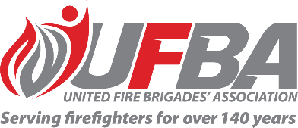
Expression of Interest Form for:
UFBA Volunteer Field Experts – Operational support
Group Overview | This Volunteer Field Expert Group aims to provide a forum that values and acknowledges the expertise within UFBA membership and better enables the UFBA to draw on this expertise, with a focus on operational support.  The UFBA recognises that it is important for Ops Support roles across the country to be connected and heard.  There are many FENZ projects underway which this group may have an interest in and provide expert advice on. This group will assist the UFBA to advocate accurately on your behalf and we will be encouraging the group to share ideas and initiatives for improvement relevant to operational support roles.
Date open | 26/08/2026 | Date closes | 16/09/2026
Volunteer Field Expert Requirements
Expertise & Experience | As this group will provide advice on all aspects of operational support, we welcome members who have a broad understanding of, and experience in, volunteer operational support roles.
Commitment | While the group is in early stages, we expect this to be approximately one hour monthly online meetings. This may develop based on what the group decides to proceed with. We also understand and respect your time, so the group will help determine future commitments.

Your Details
Name |  | Brigade, Rank/Role
Phone |  | Email
Please describe your expertise and/or experience relevant to the requirements of this Volunteer Field Expert group. We recommend attaching your CV if you are referring to external experience.

Please describe your interest relevant to the requirements of this Volunteer Field Expert group.

Please return this form by the close date (Wednesday 16 September 2026) to connect@ufba.org.nz

